Project Log Template
CIS 4020/CSC 2100 Full-Stack Development Project | Weeks 4, 6, 10, and 12
There is no length requirement and it should only take a few minutes. Logs exist so that the project stays alive and help us adjust while there is still time. A log is met when it is submitted on time and reports real progress. It is not graded on writing quality or length.
Before you fill this out. Review What Progress Looks Like in the project instructions. A log reporting no progress counts the same as not submitting one at all.
See the Tentative Schedule in Course Information for specific due dates.

Log
Field | Entry
Name | Korbin richard
Log number and week | 1
Date | 9/13/26

What I built or worked on since the last log:
Ive worked on expanding my knowledge of unity and game development.
Worked a bit through unitys integrated tutorials

What is next:
I want to continue to complete the unity integrated tutorials.
Start my own build on the basic game mechanics player controller camera basic models.

Where I am stuck, or what I need:
Main issue isnt necessarily time but I just studying for tests in other classes and stuff leaves me without much effort to be placed in the project I hope this would be easier to put time into after the tests im worried about pass.

Resources I used since the last log (tutorials, documentation, AI, people):
https://learn.unity.com/pathways

I completed the unity tour templete (walkthrough of the editor and tools present)
course : 3d beginner game: roll a ball at 25% complete.

Ive watched many youtube videos on the topic about unity and its strengths and some good to know info.
https://www.youtube.com/watch?v=iqlH4okiQqg
https://www.youtube.com/watch?v=vFjXKOXdgGo&t=884s
https://www.youtube.com/watch?v=97PeSdLarns&t=363s
https://www.youtube.com/watch?v=aMgB018o71U&t=900s

You may include screenshots of your app or code if you find them helpful, but they are not required.
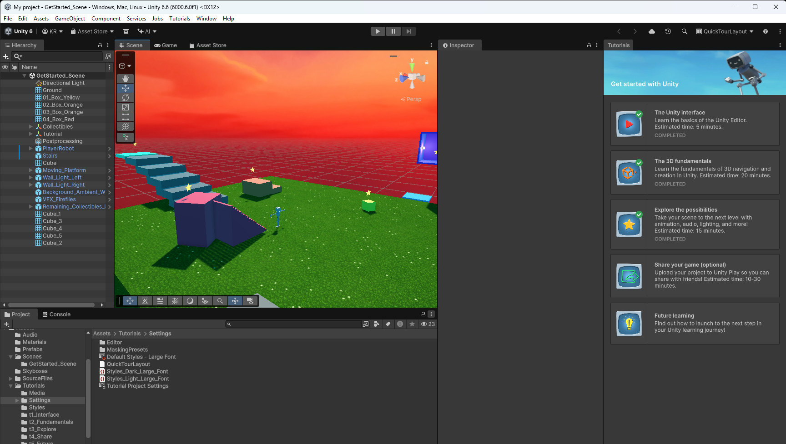
Attach: your AI conversations since the last log, as PDFs. If you used none, say so.

